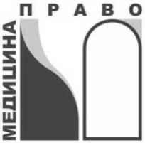
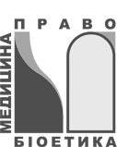
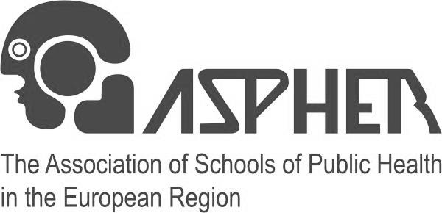
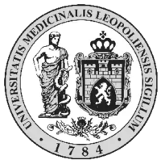

ASPHER Human Rights in Patient Care Core Network Summer School
“Human Rights in Patient Care –Teaching and Training”

18 – 22 July 2016, Lviv, Ukraine

18 July 2016 (Monday)

16.00 – 22.30 | Sightseeing / Get together  (Questions on Human Rights and Health Care will be  disseminated for review of answers during sessions tomorrow)
`
19July 2016 (Tuesday)
Positioning Health Law, Bioethics, Public Health and Human Rights in Patient Care
08.00 – 09.00 | Breakfast, Registration of Participants
09.00 – 10.00 | Welcome, Introduction of Participants &Programme Presentation  I.Senyuta,R.Otok, J. Overall
10.00 – 11.00 | Introduction to ASPHER HRPC Core Network and Resources  Practitioner Guides,Patient-Friendly Guides,  Online Resource Center and Virtual Library (Community of Practice),  Legal Fellows, Junior Faculty Scholars and HRPC Leadership Programme,  Academic Courses & Professional Training  R.Otok, J.Overall, Y.Gorshkova
11.00 – 11.30 | Break
11.30 – 12.30 | European Health/Medical Law: Concept, Key Features& Practical Illustrations  (including European Court of Justice and health rights)  Facilitator : Andre den Exter
12.30 – 13.30 | Bioethics, Medical Ethics: Concepts, Key Features & Practical Illustrations  Panel Discussion: J. Garcia Amez, M.Peled-Raz, A. den Exter, D. Larios Risco
13.30 – 14.30 | Lunch Beak
14.30 – 15:00 | Human Rights in Health Care:  Educational Game on International and Regional Standards& Review of Homework Assignment I  Facilitators: K.Selli and Y.Gorshkova
15.00 – 15.45 | HumanRightsinPatientCare: Concepts, KeyFeatures  Facilitator: J.Overall
15:45 – 16.30 | BalancingHRPCandPublic Health (including public health ethics)  Facilitator: M.Peled-Raz
16.30 – 17.00 | Navigating the Community of Practice: Topical Modules  & Assignment to Working Groups  Facilitators: J. Overall, Y. Gorshkova
20July 2016 (Wednesday)
08.00 – 09.00 | Breakfast
09.00 – 10.30 | Human Rights in Patient Care Practitioner Guides -  Patients’ Rights and Responsibilities:  International and Regional Standards and Mechanisms;  Example of National Standards; Patient-friendlyGuides - purpose, use, effectiveness  Facilitators: V. Zopunyan, A. Grigoryan
10.30 – 11.30 | Human Rights in Patient Care Practitioner Guides –  Health Care Provider Rights and Responsibilities:  International and Regional Standards and Mechanisms; Examples of National Standards (Armenia, Georgia, Macedonia, Romania, Ukraine)  Facilitator: IrynaSenyuta  Discussion with participants who are members of above country teams who wrote or update the Practitioner Guides
11.30 – 11.45 | Break
11.45 – 13.15 | International and Regional Human Rights Mechanisms –  Examples from Practice Applied to Patient Care: Use in teaching and training  (1) European Court of Human Rights (ECtHR) & Strategic Litigation-  Facilitator: T. Dekanosidze
(2) UN Human Rights Treaties and Treaty Bodies – Facilitator:V. Zopunyan
(3) Universal Periodic Review (UPR) – Facilitator:T. Metreveli
(4) Shadow Reports– Facilitator: A.Shaf
(4) Special Rapporteur on Right to Health - Facilitator: K. Selli
13.15-14.00 | LunchBreak
14.00 – 15:15 | Confidentiality and/or Privacy: Breach of Duty or Violation of a Human Right,  & What is the Difference?  Facilitators: A. den Exter, M. Peled-Raz
15.15 – 15.30 | Break
15.30 – 17.00 | HRPC LEADERSHIP  Facilitator: S.Babich
21July 2016 (Thursday)
08.00 – 09.00 | Breakfast
09.00 – 10.00 | HRPC LEADERSHIP  Facilitator: S. Babich
10.00 – 11.00 | Review of Homework Assignment II:  HRPC Quiz (International and Regional PG Chapters)  Facilitator: D. Larios Risco
11.00 – 11.20 | Break
11.20 – 13.00 | Practitioner Guides & Health and Human Rights Resource Guide  - Examples of use in teaching and training:  (1) Academic courses  Facilitators: M. Torosyan, T. Metreveli  (2) Workshops and seminars for practicing lawyers and health care providers  Facilitators: A. Grigoryan, A. Shaf
13.00 – 14.00 | Lunch Break
14.00 – 15.00 | MigrationImpactonHealthSystems, Services, Access &HRPC -  Identifying HRPC issues, & applicable patient and provider rights and responsibilities  Facilitators: D. Larios Risco, A. Shaf. M. Torosyan
15.00 – 15.30 | Break
15.30 – 17.00 | HRPCSCHOLARSHIP: Howtowrite a scholarly paper  Facilitators: O. Mazuenko and Sue Babich
22July 2016 (Friday)
08.00 – 09.30 |  | Breakfast
9.30 – 11.00 |  | Participant Discussion: National Level Experiences in HRPC  (1) Exhausting National Remedies & Use of ECtHR cases at the national level –  Facilitator: T. Dekanosidze  (2) Working with ombudspersons and parliamentary committees  Facilitator: A. Grigoryan-  (3) Other examples from participants’ experiences  Facilitator: J. Garcia Amez
11.00- 11.30 |  | Break
11.30 – 12 :15 |  | Medical-legal University Clinics:  Purpose, establishment, functioning, & student experiences  I. Senyuta
12.15 – 13 :00 |  | MedicalNeutrality and Human Rights in Patient Care:  Content and exercises for teaching and training  (including video and Practitioner Guide)  Facilitator: D. Klapatyi
13.00 – 14.00 |  | Lunch Break
14.30 – 15.30 |  | Working Groups – Topical Modules  (including uploading information for topical modules on Community of Practice)  Facilitator: Y. Gorshkova,
15.30 – 16.30 |  | Topical Modules – Review and Critique: finalizing on Community of Practice  Y. Gorshkova,J. Overall
16.30 – 17.00 |  | Conclusions. Certificate ceremony
18.00 – 19.00 |  | Dinner

The Association of Schools of Public Health in the European Region (ASPHER)
ASPHER Brussels | T: +32 2 735 0890 | S: aspherskype | E: office@aspher.org

